**SERIS**

Solar Energy Research Institute Singapore



Cloud Based Realtime Analytical Monitoring of Photovoltaic Systems and Weather Parameters Project

**User Interface Specifications**

|  |  |
| --- | --- |
| Filing Reference | SE25PT7SERIS/SERIS/SPEC/REQUIREMENT/UIS |
| Document Title | User Interface Specifications |
| Version | 1.0 |
| Prepared by | Nay Lin Aung |
| Date Created | 20/04/2018 |

|  |  |  |
| --- | --- | --- |
| **Approved by:** | | |
| Name | Designation | Date |
| Treza Bawm Win | System Architect |  |
| **Authorized by:** | | |
| Name | Designation | Date |
| Kaung Myat Bo | Project Manager |  |

1. **History**

|  |  |  |  |
| --- | --- | --- | --- |
| **Revision** | **Date** | **Author/Editor** | **Reason** |
| 1.0 | 20/04/2018 | NayLA | Initial version |
|  |  |  |  |
|  |  |  |  |
|  |  |  |  |
|  |  |  |  |
|  |  |  |  |
|  |  |  |  |

|  |
| --- |
| 1. Table of Contents |
| Appendix: |

User list

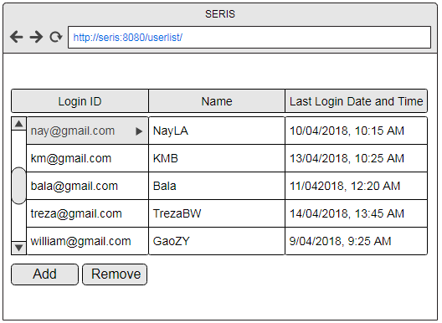

User

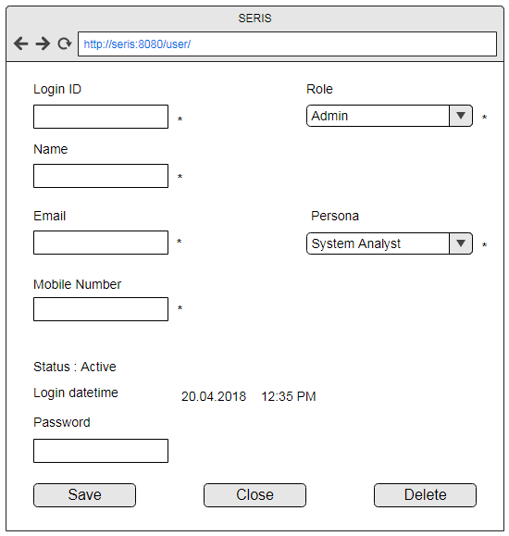

Device List

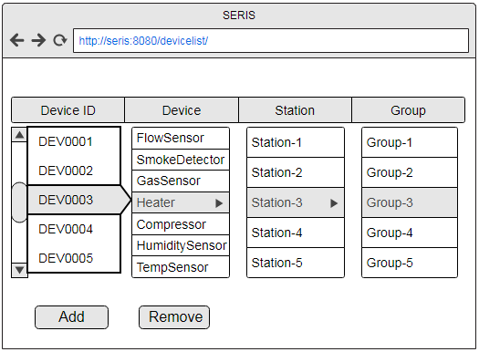

Device

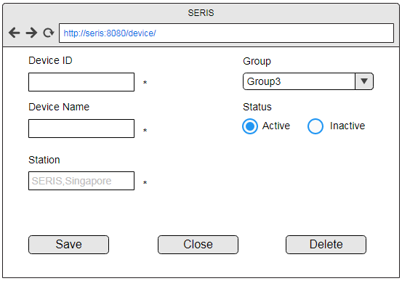

Device Group

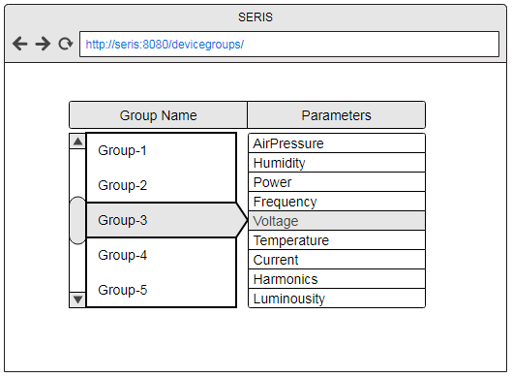

Group

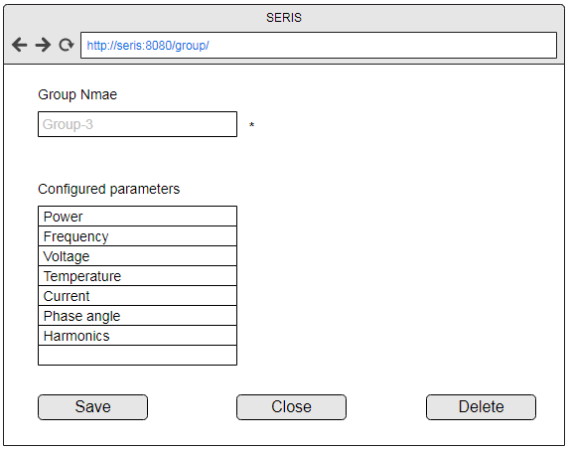

Station List

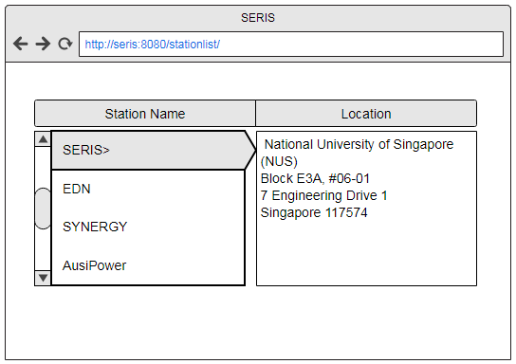

Station

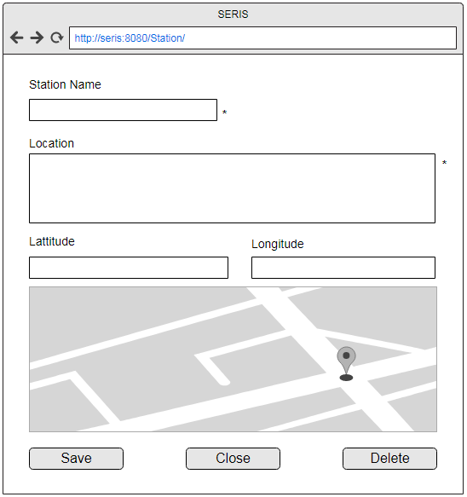

Personas

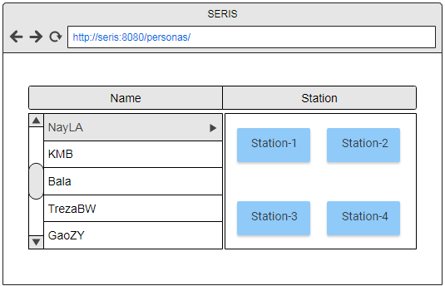

Persona

